Accessing and Using your Microsoft Office 365
- Teams application
- Open a web browser and go to office.com and then click on “Sign in”
  - If you are on a shared computer, you may want to use the “in private/incognito” mode on your web browser as it will not save any of your information while you are on the internet. To access your “in private/incognito” mode, click on the ellipsis (three dots in the top right of your web browser), right below the X.
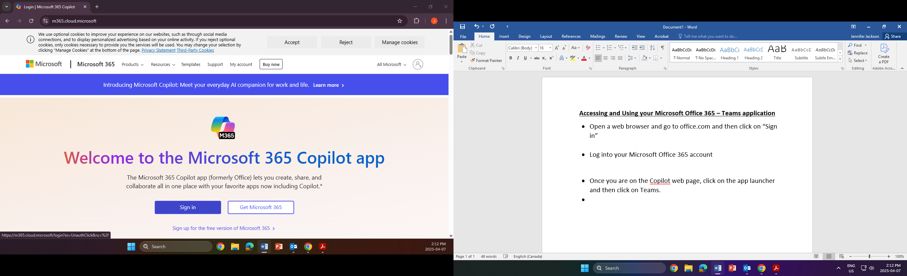
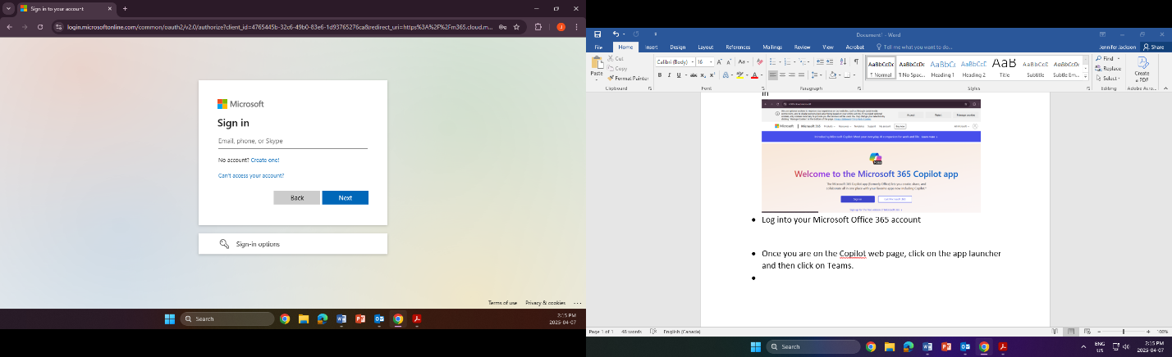
- Log into your Microsoft Office 365 account using your unbq email (firstname.lastname@unbq.ca) and password. Click “Next” after you enter your email and then again after you enter your password.

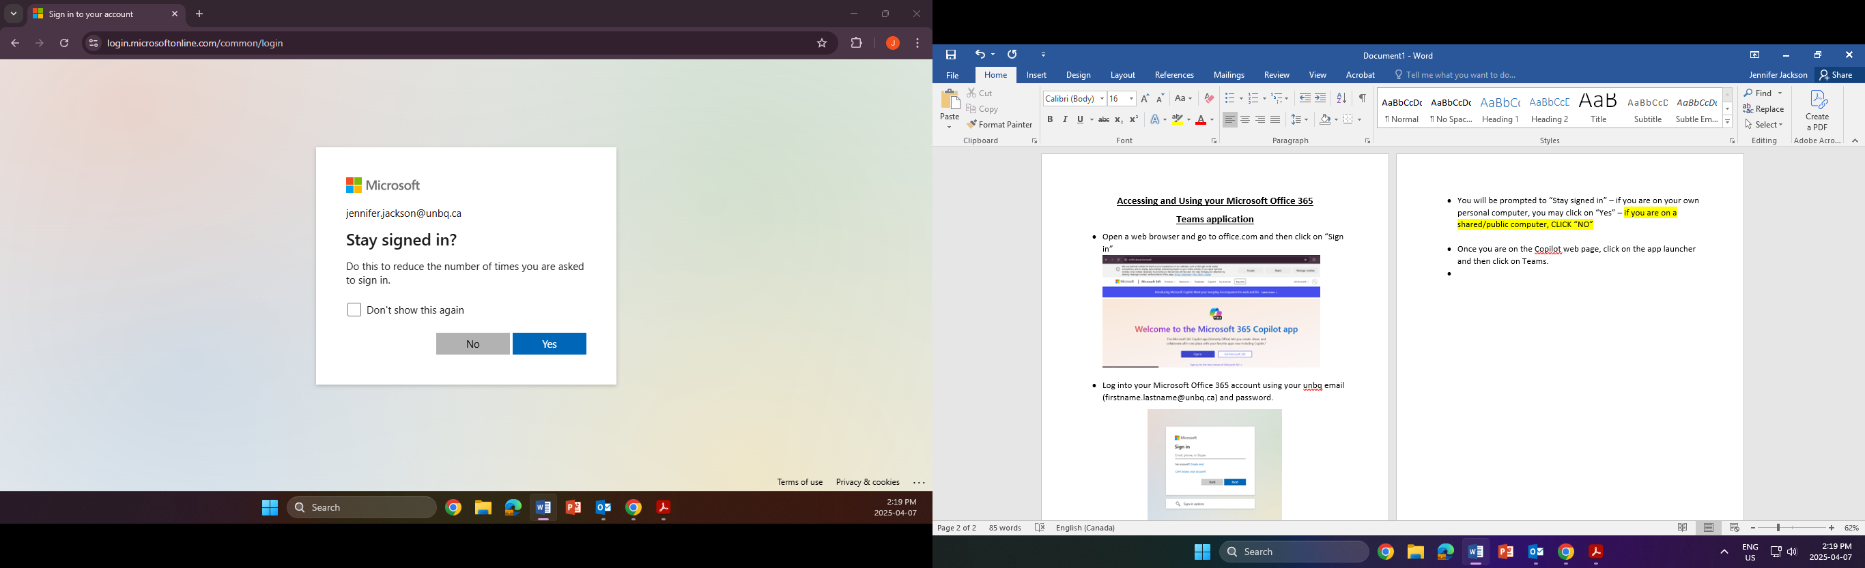
- You will be prompted to “Stay signed in” – if you are on your own personal computer, you may click on “Yes” – if you are on a shared/public computer, CLICK “NO”

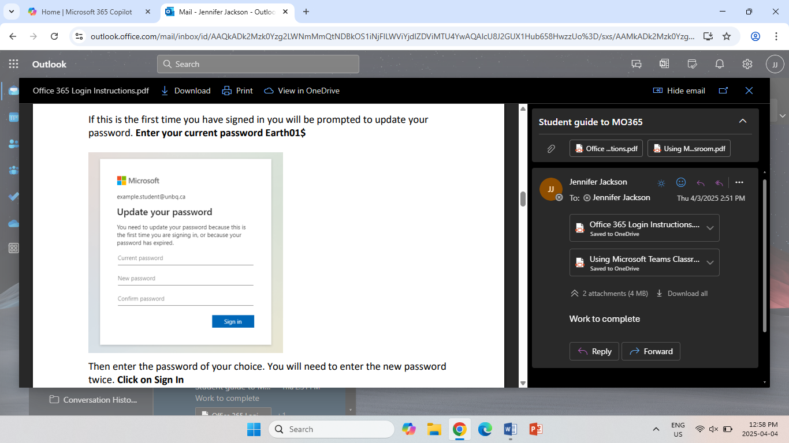
- Follow any prompts: If this is the first time you have signed in, you will be prompted to update your password (this is where you will be asked to change the temporary password IT has given you). Enter your current/temporary password Earth01$. Then enter the password of your choice. You will need to enter the new password twice. Click on “Sign in”.

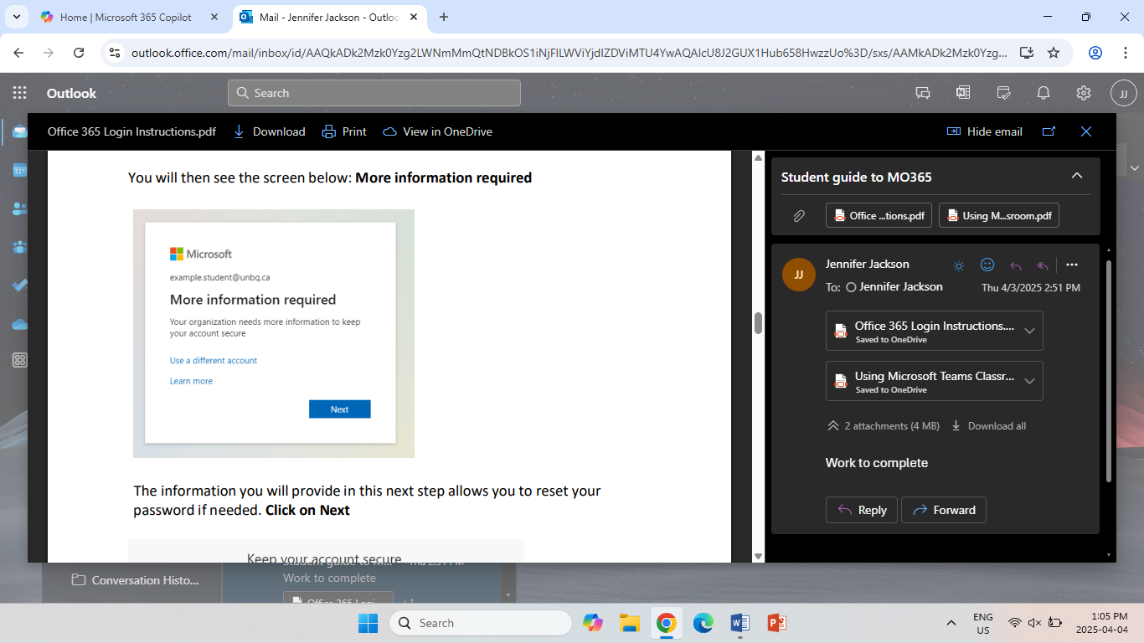
- You will then see the screen below: More information required. Click on “Next”.

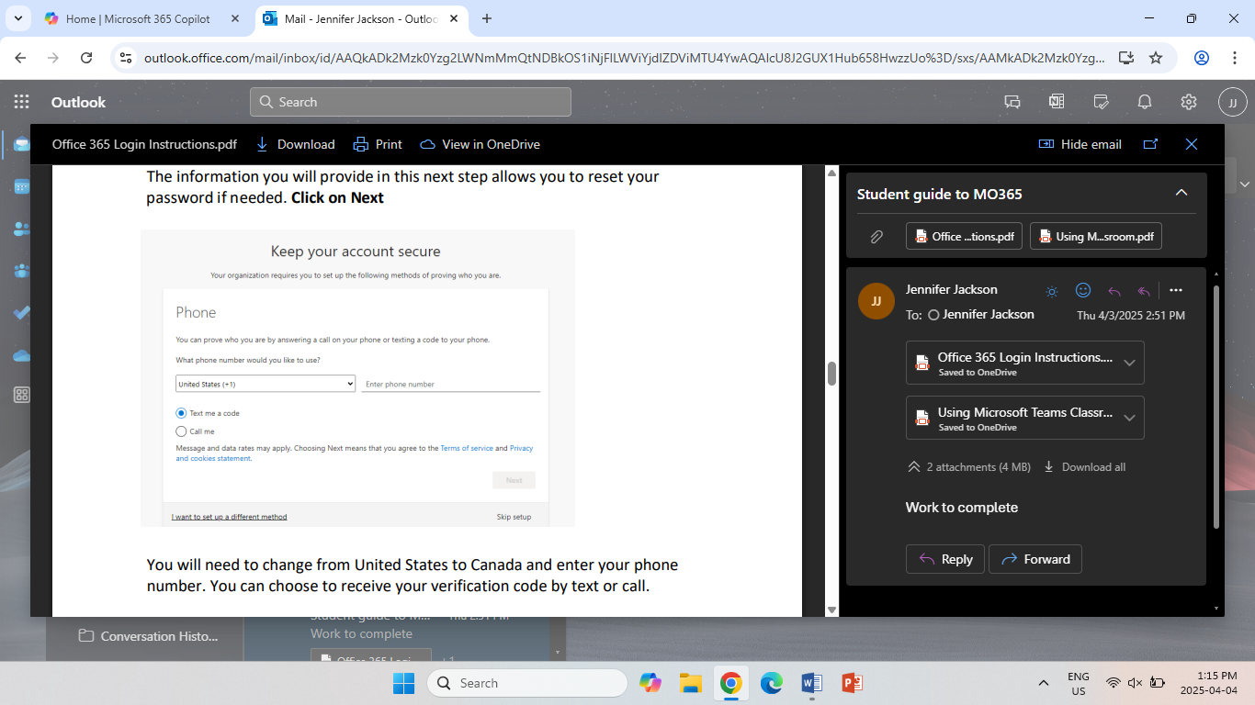
- The information you will provide in this next step allows you to reset your password if needed. You will need to change from United States to Canada and enter your phone number. You can choose to receive your verification by text or call. Click on “Next”

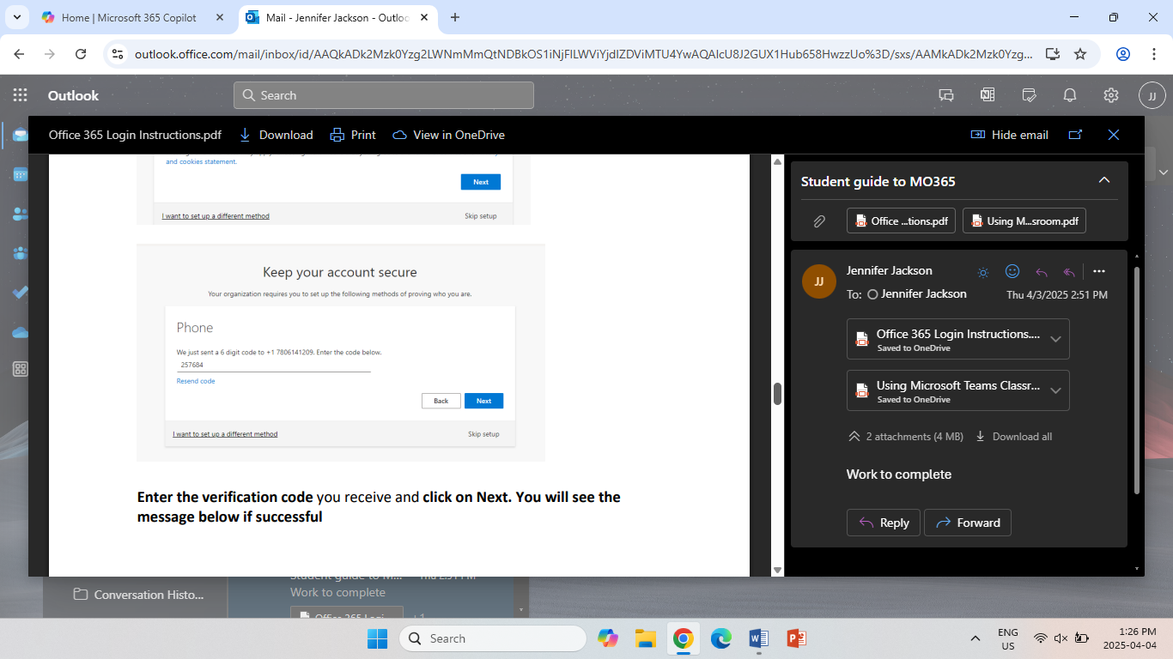
- Enter the verification code you receive and click on Next.

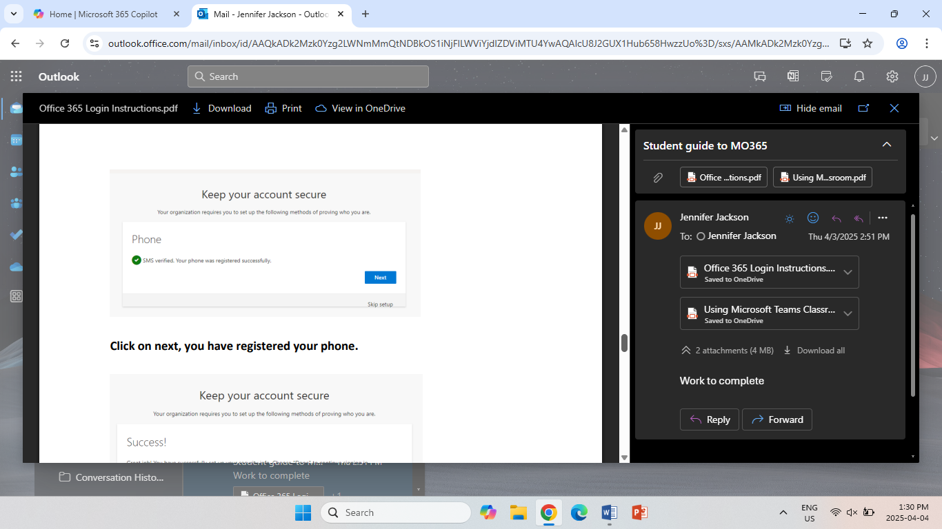
- You will see the message below if successful. Click on “Next”

- You have successfully registered your phone. You have completed the verification process. Click on “Done”.
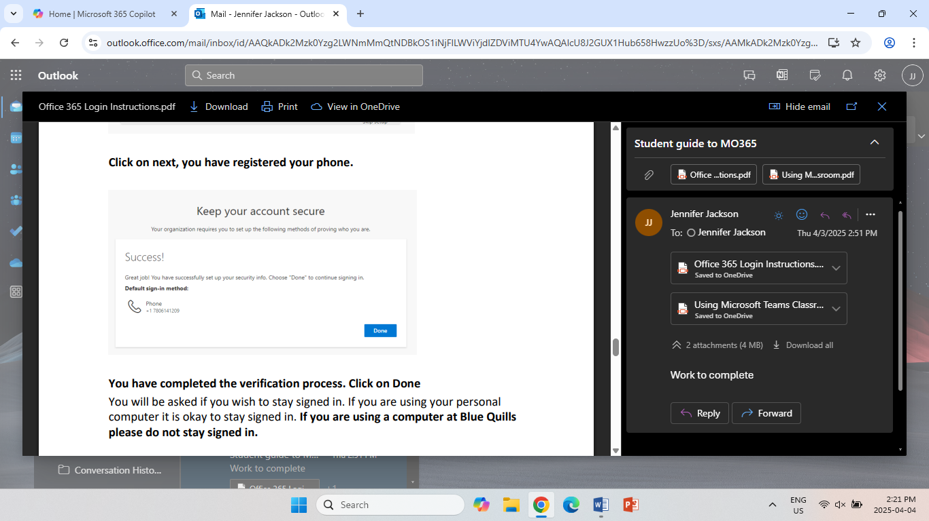

- Once you are on the Co-pilot web page, click on the “Apps” button (indicated by the blue arrow) and then click on “Teams” (indicated by the yellow arrow).
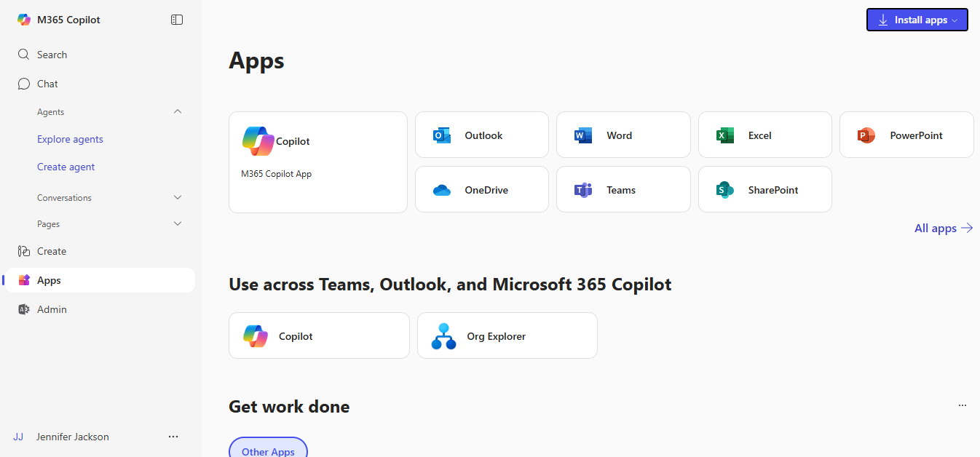

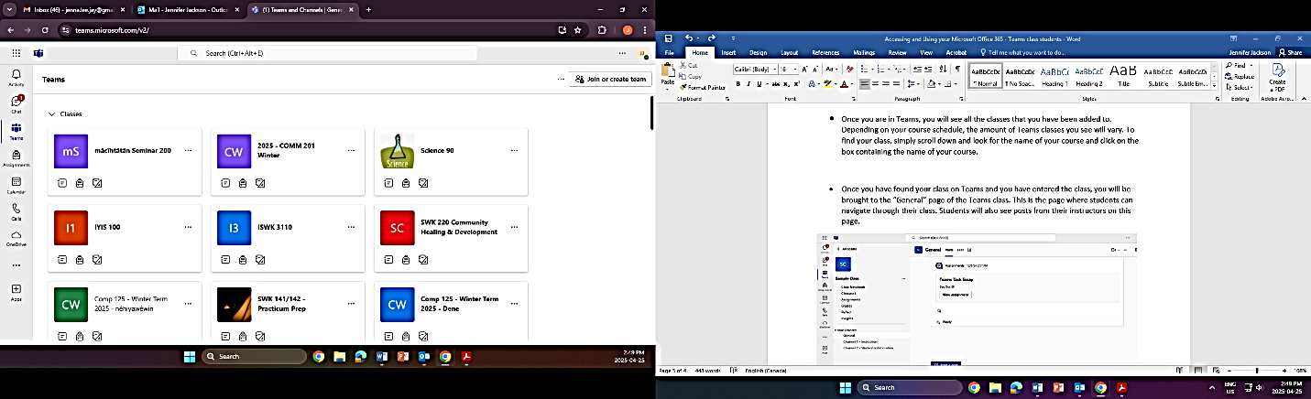
- Once you are in Teams, you will see all the classes that you have been added to. Depending on your course schedule, the amount of Teams classes you see will vary. To find your class, simply scroll down and look for the name of your course and click on the box containing the name of your course.

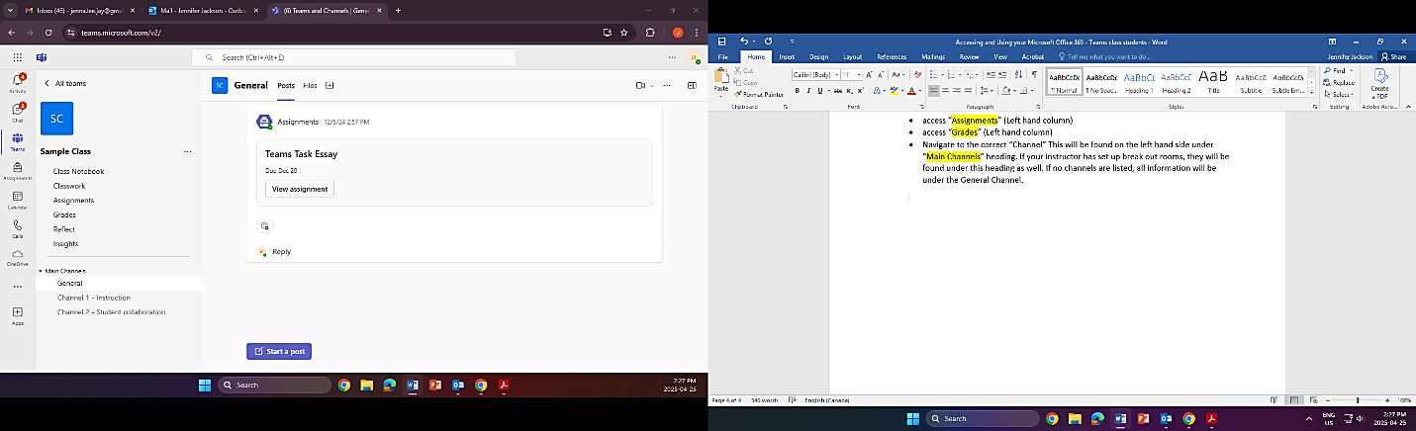
- Once you have found your class on Teams and you have entered the class, you will be brought to the “General” page of the Teams class. This is the page where students can navigate through their class. Students will also see posts from their instructors on this page. This is the page where they can access files for the classroom such as the course syllabus. Simply click on “Files”.

When students get to this page, they can:
- post messages to the other members of the Teams class. (Remember that everyone in the class can see these messages.) All you need to do is click on “Start a post” button.
- access “Assignments” (Left hand column)
- access “Grades” (Left hand column)
- Navigate to the correct “Channel” This will be found on the left hand side under “Main Channels” heading. If your instructor has set up break out rooms, they will be found under this heading as well. If no channels are listed, all information will be under the General Channel.
- Student may also wish to use the “Chat” option provided. This is where students can chat one on one with their instructor or another student. Simply click on the “Chat” icon. To start a “New chat”, click on the icon, type the name of the person you want to chat with, go to the bottom of the screen and start typing where it says, “Type a message”.
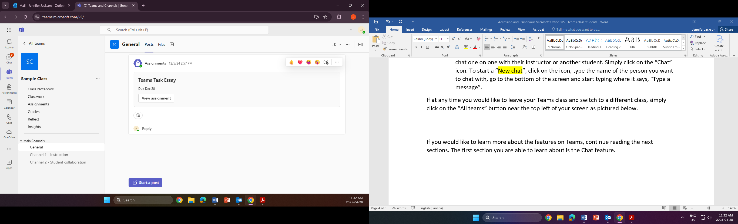
*If at any time you would like to leave your Teams class and switch to a different class, simply click on the “All teams” button near the top left of your screen as pictured below.

If you would like to learn more about the features on Teams, continue reading the next sections.

- General Channel
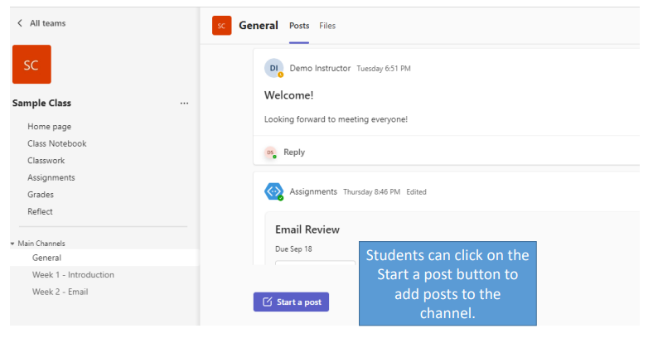
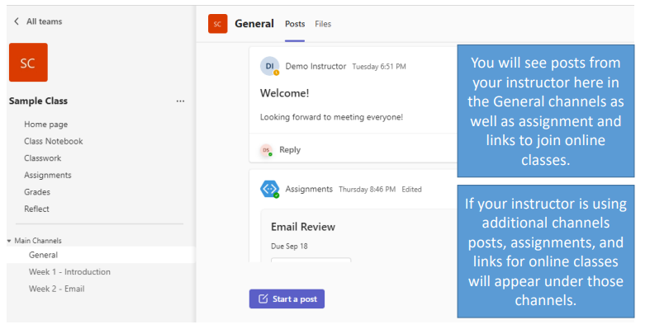

- Using the Chat feature
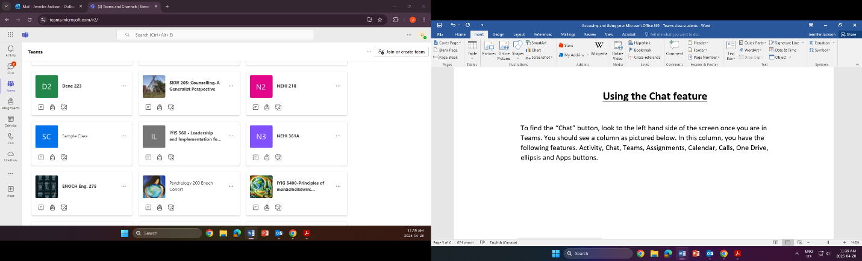
To find the “Chat” button, look to the left hand side of the screen once you are in Teams. You should see a menu as pictured below. In this menu, you have the following features. App Launcher, Activity, Chat, Teams, Assignments, Calendar, Calls, One Drive, ellipsis and Apps buttons. Click on the “Chat” icon.
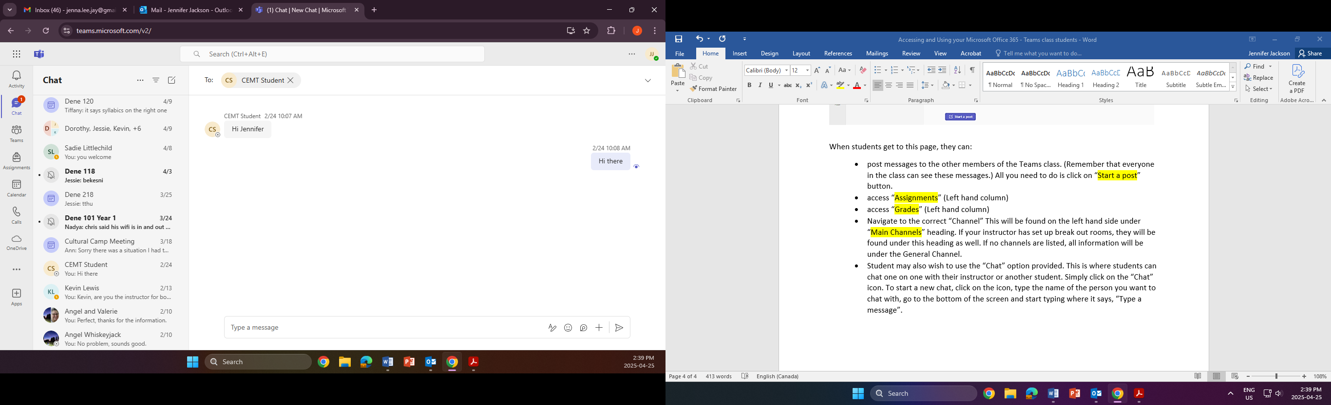
This is the “New Chat” icon. You will find this in the upper left hand corner.
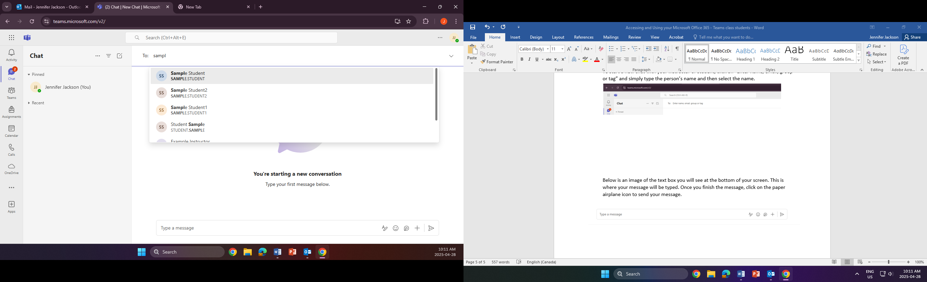
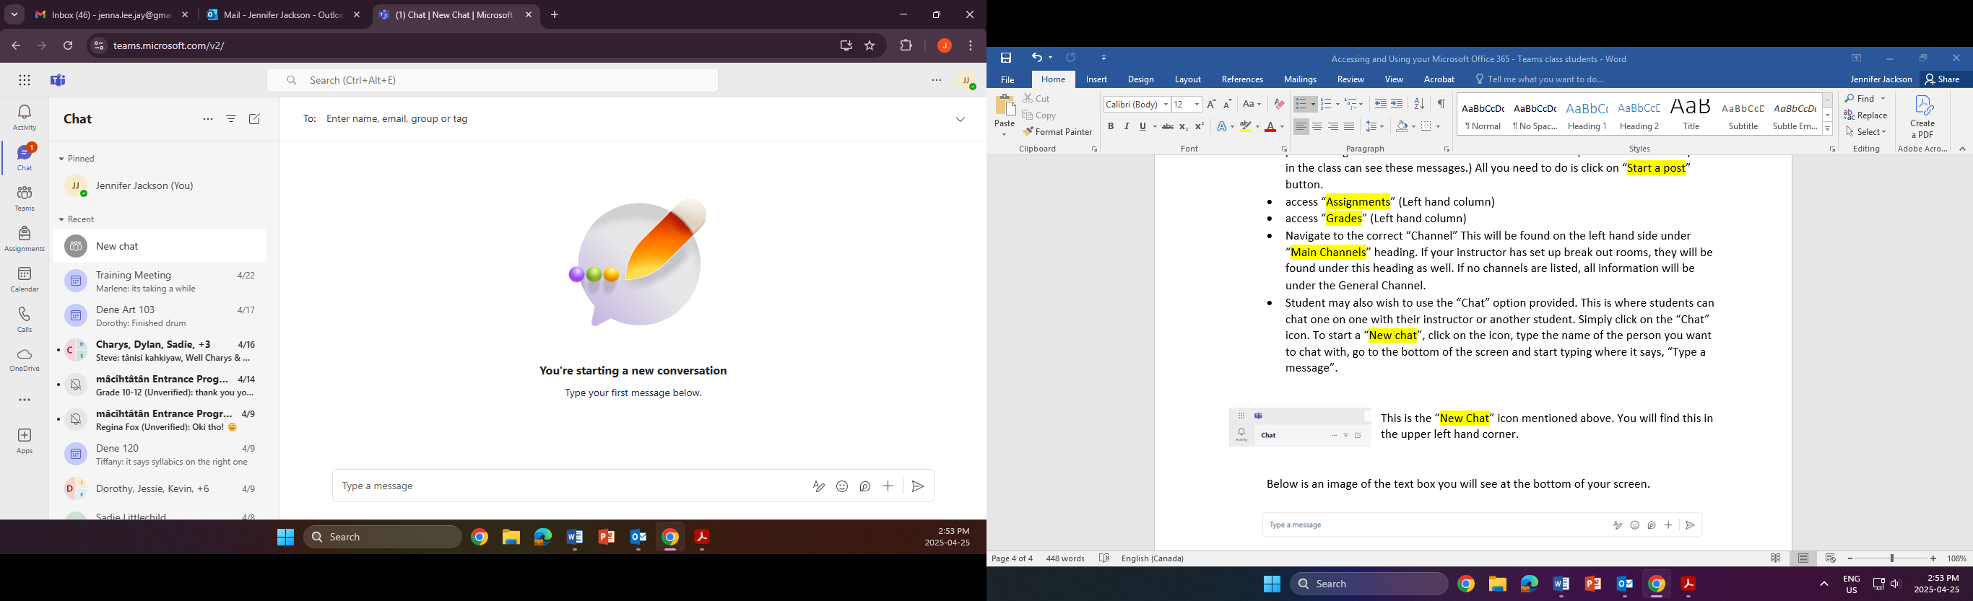
To start a new chat with your instructor or student, click on “Enter name, email, group or tag” and simply type the person’s name and then select the name.

Below is an image of the text box you will see at the bottom of your screen. This is where your message will be typed. Once you finish the message, click on the paper airplane icon to send your message.

- Accessing Files posted in Teams class
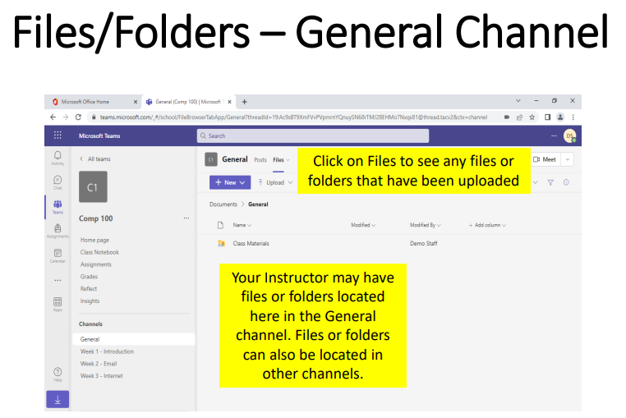
To find files your instructor uploaded, under the General page, click on “Files” (Indicated by the blue circle below).
- Assignments

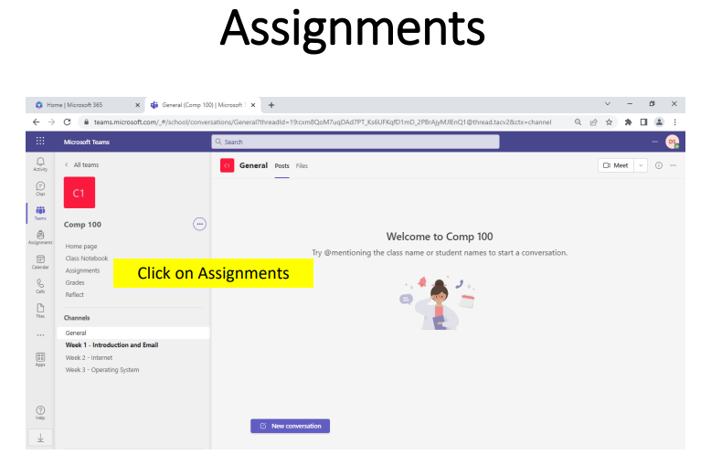
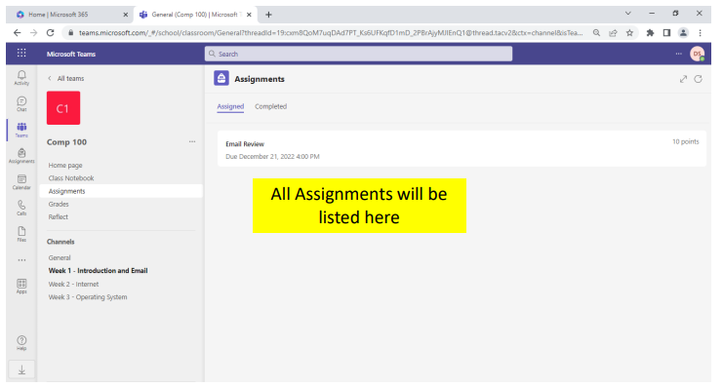
To access your assignments, click on “Assignments”
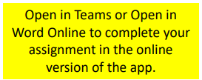
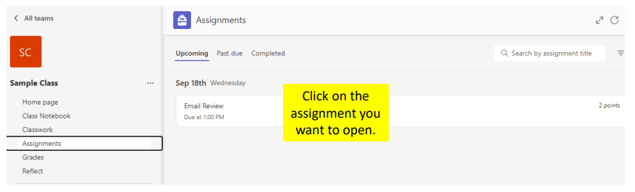
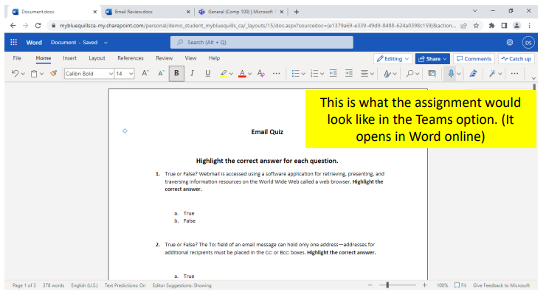
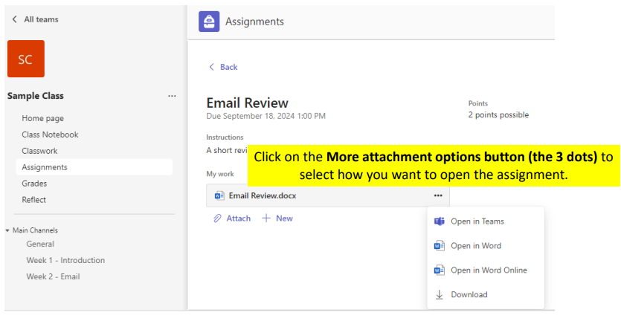
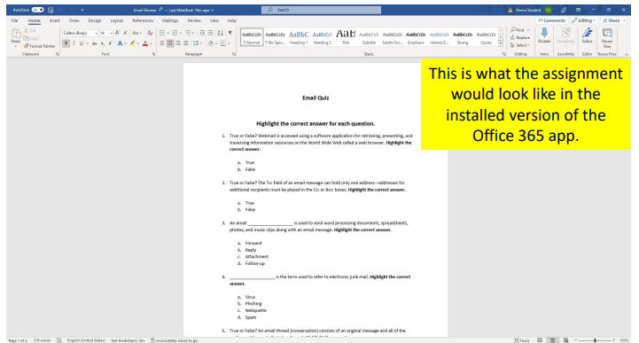
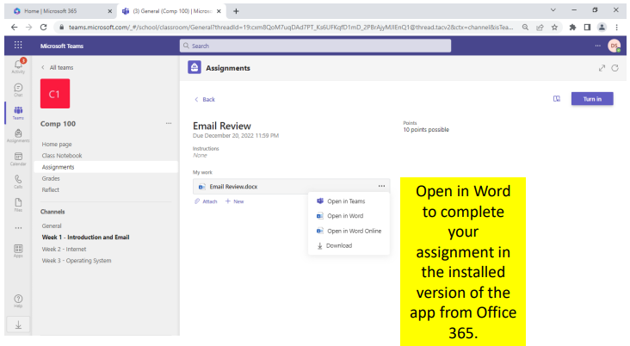
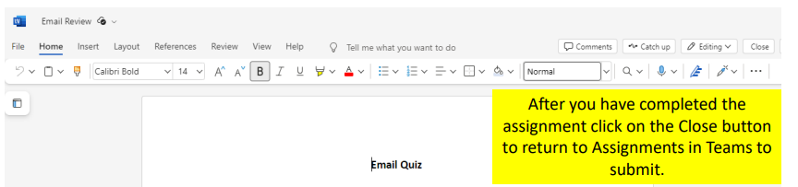
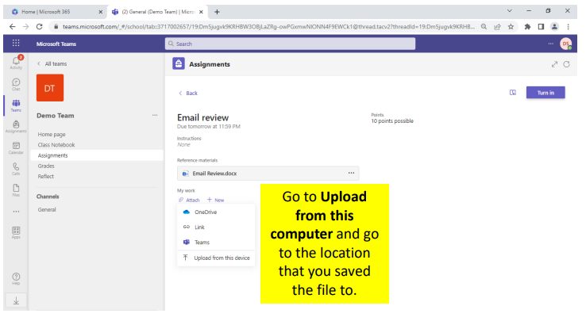
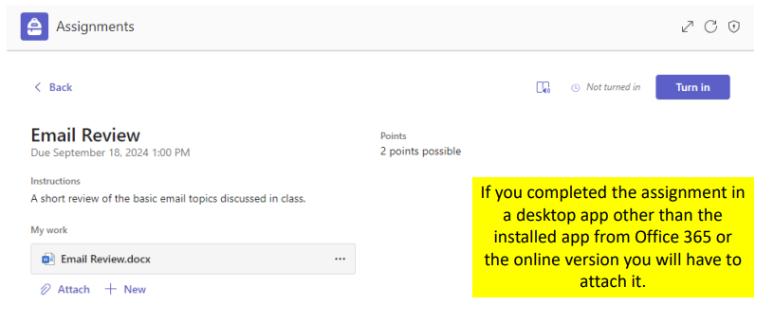
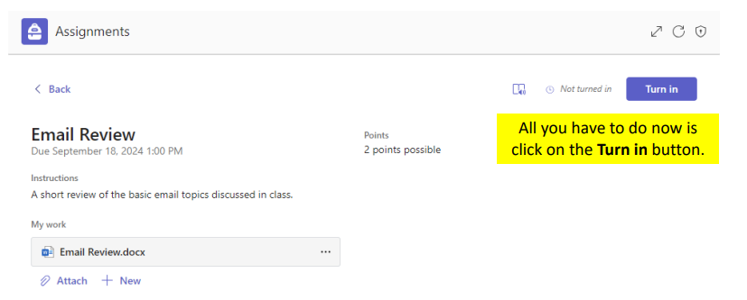

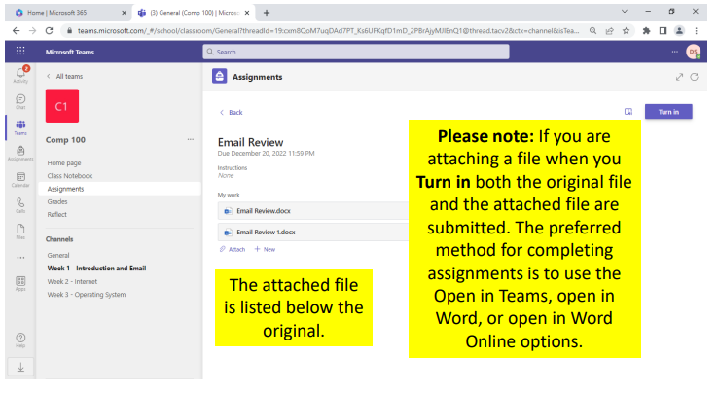
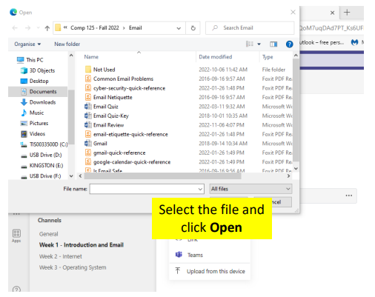
- Joining an online class in Teams
If you would like to join an online class, you will need to log into your Microsoft Teams account.
- Go to office.com and sign into your unbq email account. Once you have signed in, you will need to click on Apps and then select Teams.

- Once you have entered into the Teams area, locate your class and click on it.

- When you have been brought to the online class’s General page, you should be able to see the meeting bubble as pictured below. To enter the online meeting, simply click on the “Join” button.
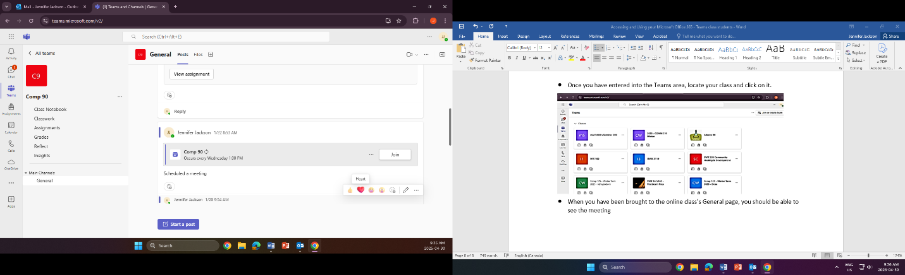
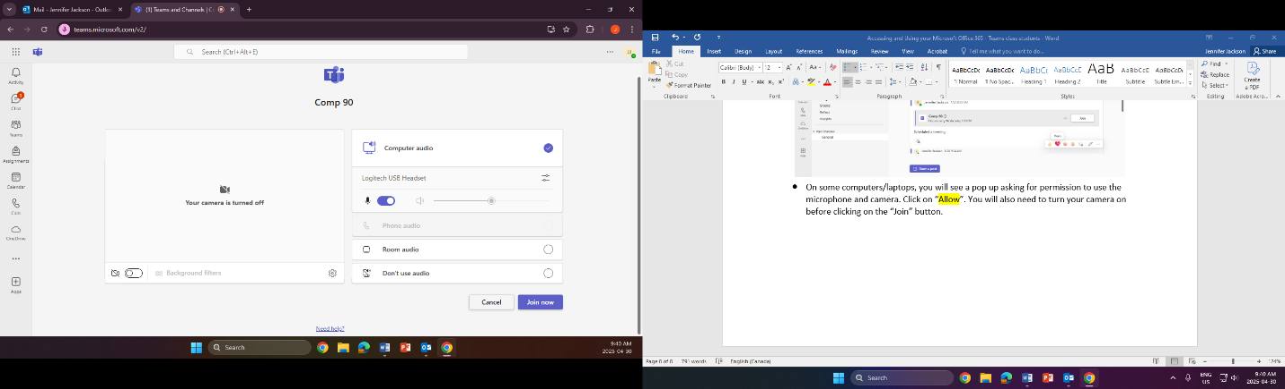
- On some computers/laptops, you will see a pop up asking for permission to use the microphone and camera. Click on “Allow”. You will also need to turn your camera on before clicking on the “Join” button.
Turn Camera On

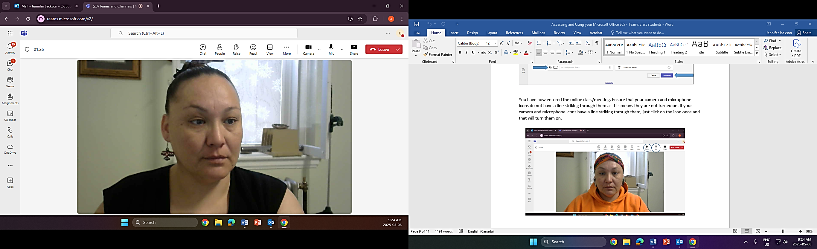
You have now entered the online class/meeting. Ensure that your camera and microphone icons do not have a line striking through them as this means they are turned off. If your camera and microphone icons have a line striking through them, just click on the icon once and that will turn them on.

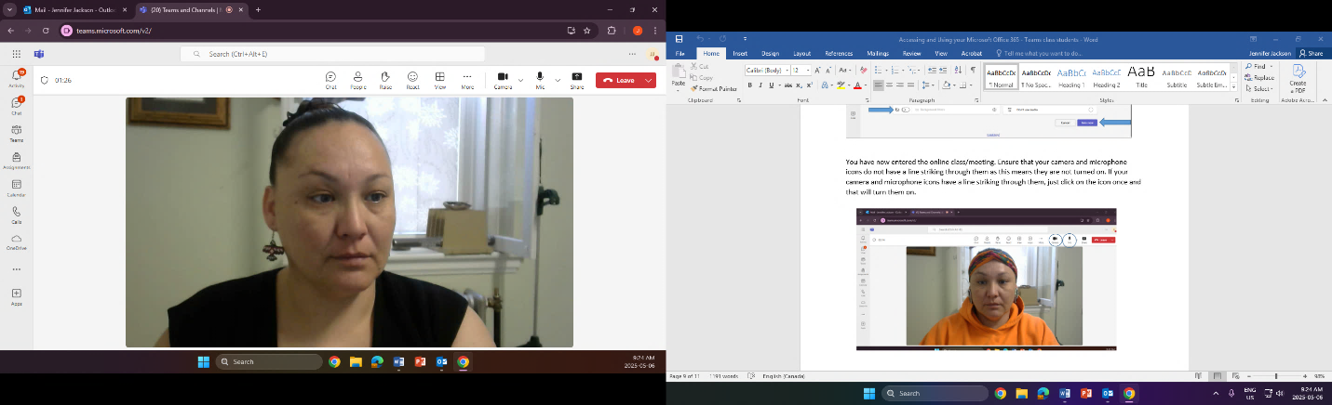
As you will see, there are many features that you may use during your class/meeting. If you look at the top of your camera view, you will see the following:
- Chat
  - This feature will allow you to chat with others within the class/meeting.
- People
  - This feature shows you how many people are attending the online class/meeting.
- Raise
  - Raise is a feature that allows you to virtually raise your hand if you have a question/comment
- React
  - This feature has emoji’s that allow you so show your reaction to the meeting. Similar to those you would find on your cell phone.
- View
  - View allows you to change the way you see others within the online class. You can focus on the speaker you can view everyone as a gallery or you can view them together.
- More
  - The “More” feature allows you to record and transcribe your class/meeting. You can also find the meeting info under this feature as well. You can do video effect and settings, audio settings, language and speech as well as general settings for your class/meeting. There is also a “Help” option should you wish to explore that.
- Camera
  - This is where you can turn your camera on/off during the class/meeting. When the camera is turned off, a line will strike through the camera icon.
- Mic
  - This is where you can mute yourself by turning off the mic. When the mic is turned off, there will be a line striking through it.
- Share
  - The share button allows you to share your screen within the class/meeting. You can choose to share your “Screen, window or tab’ or you can choose to share a whiteboard. Sharing your “Screen, window or tab” allows you to share documents within the class. If you choose to share the “Whiteboard”, you will be sharing a virtual whiteboard that participants can participate in.

- Leave
  - The “Leave” button allows you to either: leave the class/meeting (you will be the only one to leave) or if you select End meeting, you will end the session for all participants.
- Accessing your Grades
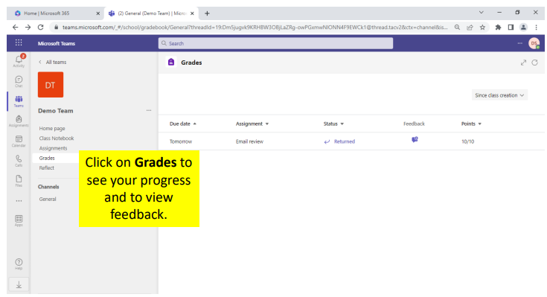

- Accessing and using your Microsoft Office Outlook Email
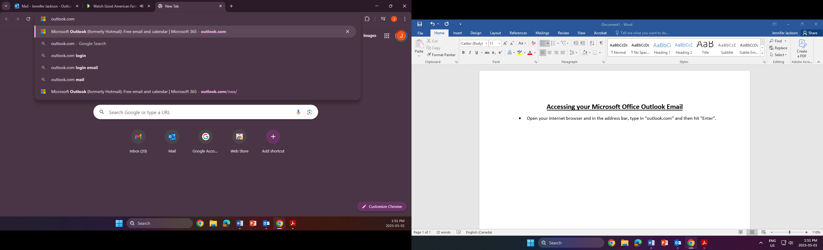
- Open your internet browser and in the address bar, type in “outlook.com” and then hit “Enter” on your keyboard.

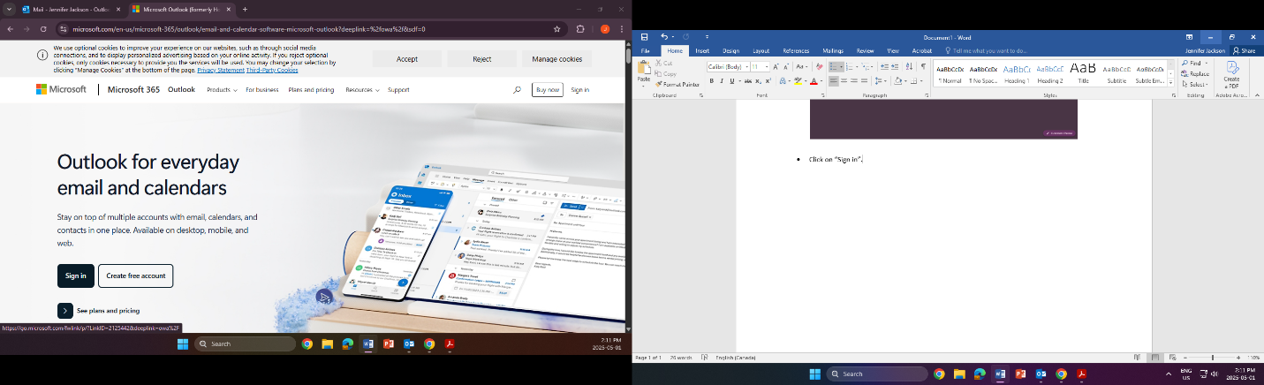
- Click on “Sign in”.

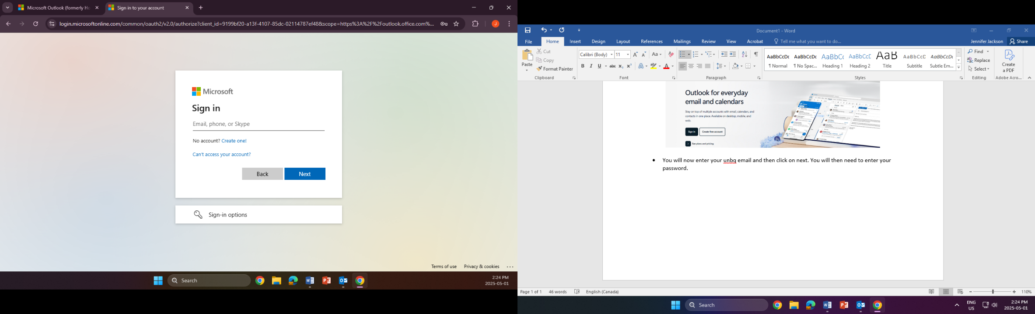
- You will now enter your unbq email (firstname.lastname@unbq.ca) and then click on next.

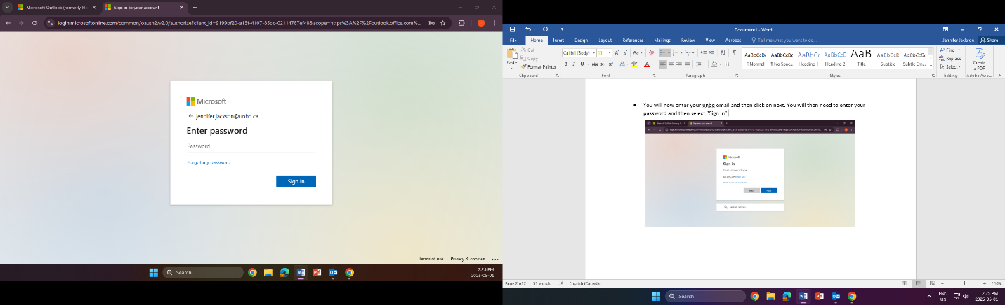
- You will then need to enter your password and then select “Sign in”.

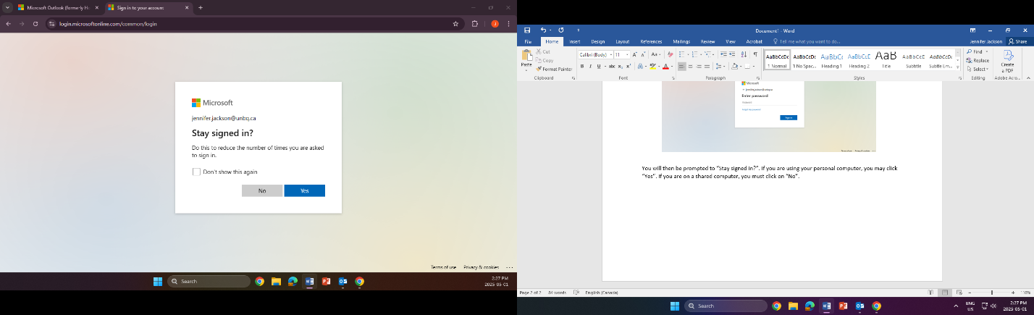
*You will then be prompted to “Stay signed in?”. If you are using your personal computer, you may click “Yes”. If you are on a shared computer, you must click on “No”. After you click on either “Yes or No”, you will be brought to your Outlook email.

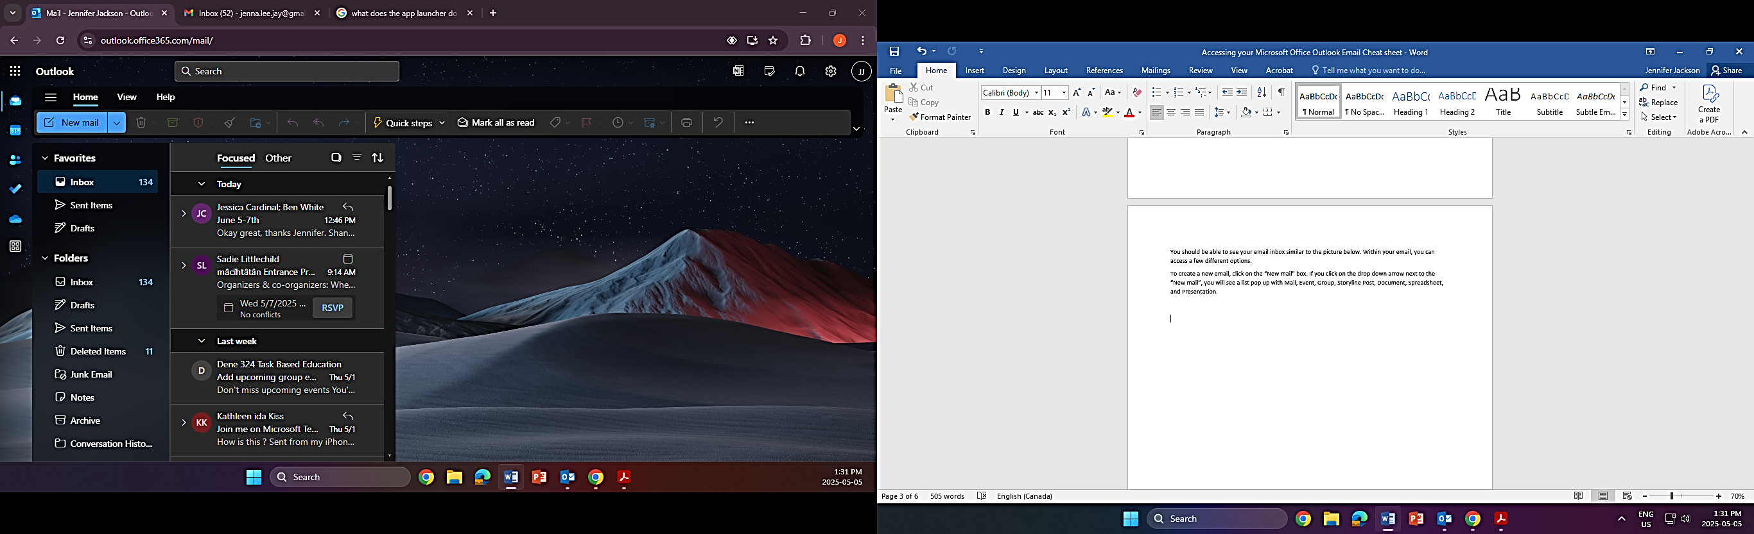
You should be able to see your email inbox similar to the picture below. Within your email, you can access a few different options.

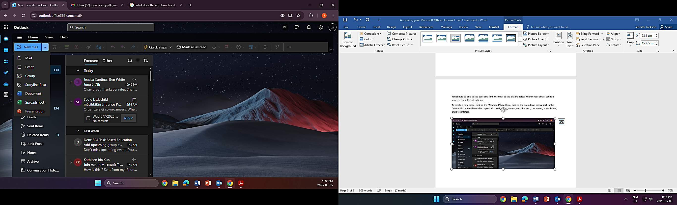
To create a new email, click on the “New mail” box. If you click on the drop down arrow next to the “New mail”, you will see a list pop up with Mail, Event, Group, Storyline Post, Document, Spreadsheet, and Presentation.

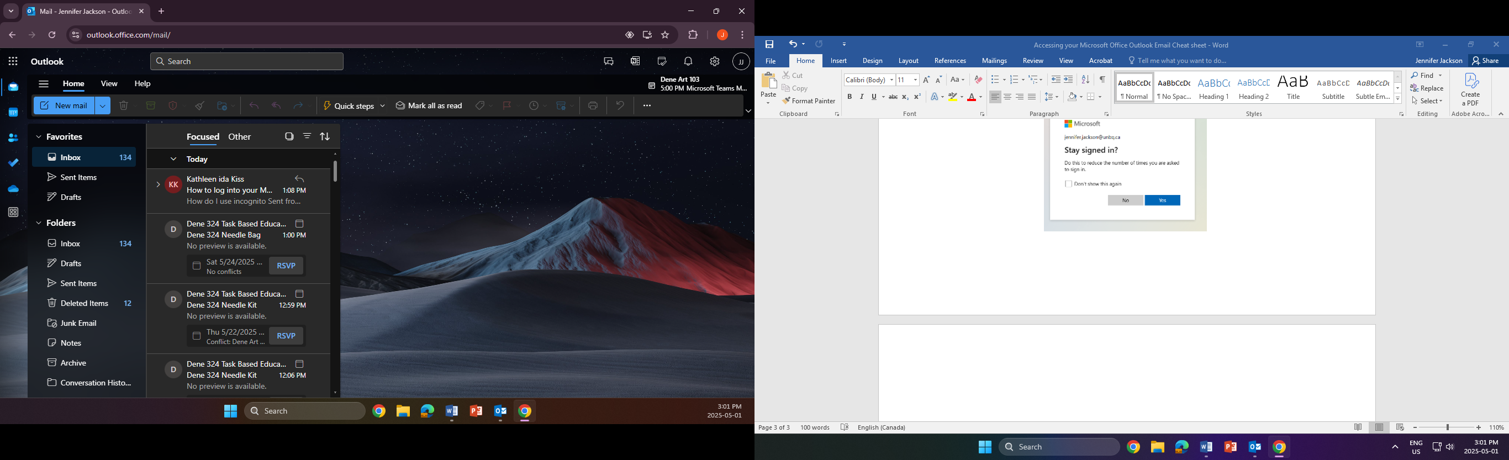
In the picture below, in the highlighted yellow section, you will see a few different icons (from top to bottom); the app launcher, mail, calendar, people, to do, one drive and more apps. Descriptions of this list are below the picture.
- The “App Launcher” is a navigation tool that provides users with a central location to access all their Microsoft cloud services, including Outlook, Word, Excel, and more. It essentially acts as a dashboard, allowing users to switch between different apps within the Microsoft 365 suite with ease.
- The "Mail" section primarily manages your email communication. It allows you to create, send, receive, and manage emails, including attachments, signatures, and organizing your inbox with folders and rules.
- The “Calendar” helps users manage their schedules by allowing them to create and organize appointments, meetings, and events. It also enables sharing and delegating calendar access, as well as viewing group calendars. Key features include reminders, color-coding, and integration with other Microsoft 365 apps.
- The "People" section, or the People page, is used to manage and interact with contacts, contact lists, and groups. Users can create, view, edit, and even delete contacts, as well as organize them into groups. It also allows for creating and managing groups, which can be used to streamline communications within specific teams or projects.
- The "To Do" is a task management feature that allows you to create and manage to-do lists, including daily lists, important items, and flagged emails.
- OneDrive enables easy sharing of files stored in the cloud. It allows users to share files attached to emails as links, instead of sending copies, which streamlines collaboration and reduces file clutter. OneDrive also provides features for file recovery and version history.
- the "More Apps" group organizes and consolidates apps, allowing users to access them without cluttering the main sidebar.

In the highlighted blue section, you will see (from left to right) “Focused” “Other” “Select” “Filter” and “Sorted: By Date”. These options assist with filtering your Inbox. Be mindful to check both “Focused” and “Other” as information is stored in both. Descriptions of this list are below the picture.

  - The “Focused” tab contains your most important email messages
  - The “Other” tab holds the rest, allowing you to prioritize your inbox
  - If you click on Select, you will see that boxes appear on each email. This allows you to select either one or more emails at a time to either move the messages to another folder or to send them to the trash.
  - If you select the Filter option, you will then be able to set up your inbox to show All emails, Unread emails, Flagged emails, emails sent directly to you, emails that have attached files, emails that mention you within them and emails that have calendar invites. Be mindful when you use the Filter option. If you do not set it back to “By date”, you may miss some emails as your inbox is still filtering.

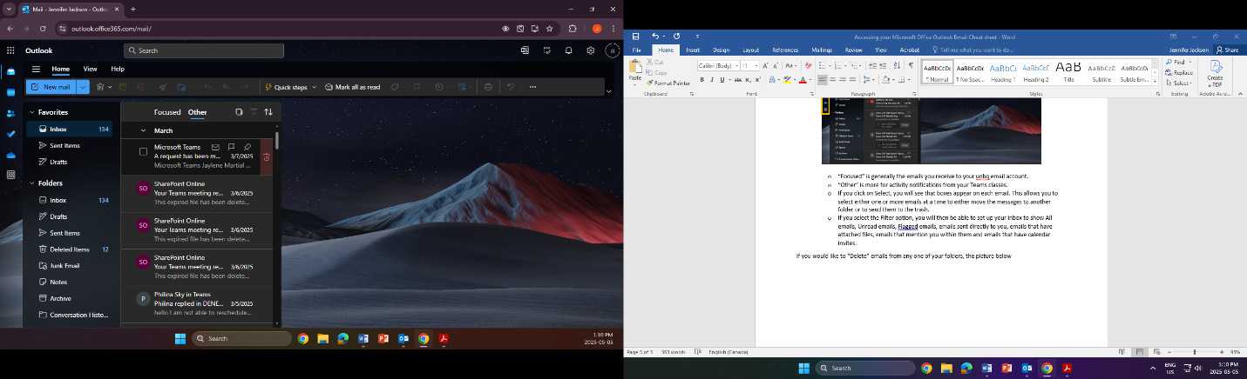
If you would like to “Delete” emails from any one of your folders, the picture below shows you where you can find the delete option. Place/hover your mouse/curser over the email you would like to delete. You will see a trash bin appear on the right side of your email. Click on the trash bin and your email has been sent to your “Deleted Items” folder.

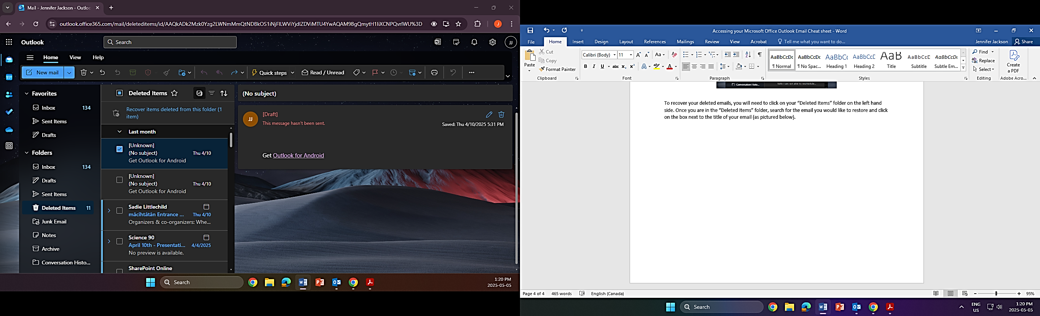
To recover your deleted emails, you will need to click on your “Deleted Items” folder on the left hand side. Once you are in the “Deleted Items” folder, search for the email you would like to restore and click on the box next to the title of your email (as shown by the blue arrow). You will then click on the “Move to a folder” icon on the menu bar above (as shown by the yellow arrow) and then click on “Inbox. This will restore your deleted email back to your Inbox.

Attach a file to an email message in Outlook
Outlook keeps track of the files you have worked on recently and suggests them whenever you decide you want to attach a file to an email message. Some file types are blocked from being sent or received. One of the most common ways of transmitting computer viruses is through file attachments. To help protect you and your recipients against computer viruses, Outlook blocks the sending and receiving of certain types of files (such as .exe and certain database files) as attachments. If you need to send one of these file types to an email recipient, we recommend using OneDrive and sending the recipient a link to the file instead.
- In a new email message, a reply, or a forwarding message, select Insert.
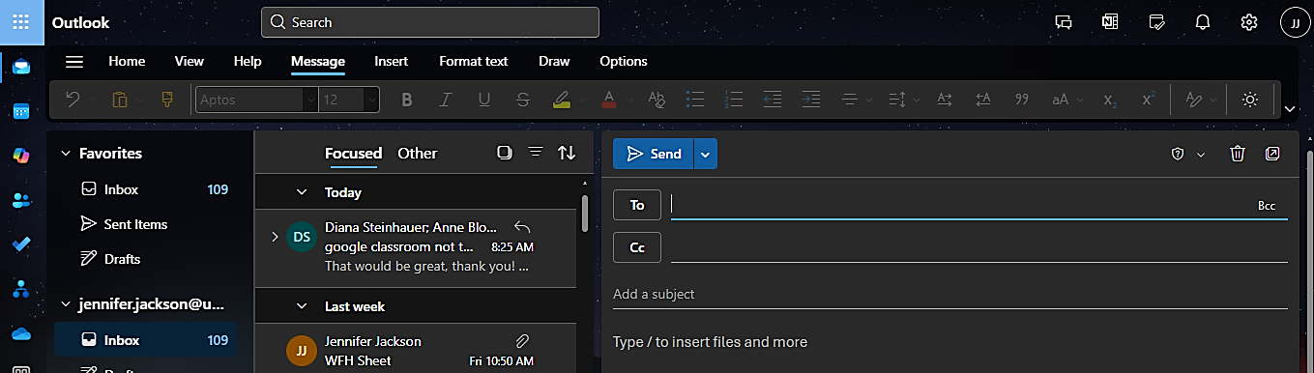
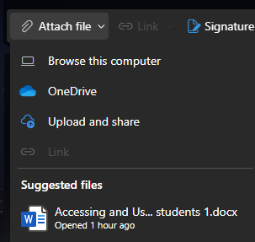
- You will then click on “Attach file”

- Select your file from one of the following locations:
  - Browse this computer
This opens a File Explorer window where you can choose a file from your computer.
  - OneDrive
Locations include OneDrive, SharePoint sites, or connected third-party cloud storage providers. Select one of the locations to open a new window and then select your attachment.
  - Upload and Share
refers to storing a file in a cloud service like OneDrive and then providing a link to that file in an email instead of attaching the file directly to the email as a traditional attachment
  - Suggested files
The three most recent cloud files you've worked on will be displayed here. These files may be on OneDrive, SharePoint, or another online document library. Select a file to attach to your email.
- Send a link or send a copy: Sending a link to the OneDrive or SharePoint file keeps the size of your email message small. If you choose to send a copy of the file, the entire file is attached to the email, just like it would be if you selected a file on your computer. If you choose to send a link to the file, you can also set the permissions on your file.

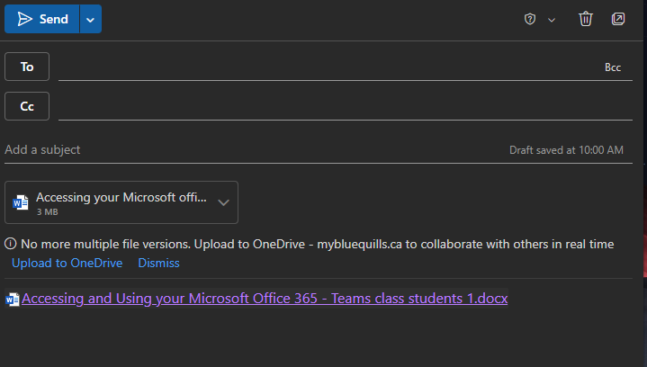
The picture below shows the difference between sharing a file from Onedrive and attaching a copy of the file you are wanting to send. The blue arrow shows the actual copy of a file. The yellow arrow shows the link that shares the file from your Onedrive. Once you see either option on your email, this lets you know that the file has been attached. If you choose to share the link, your recipients will need to ask for permission via email and you will receive and email prompting you to allow access.

- Creating an Email List
- You will need to open up Outlook.
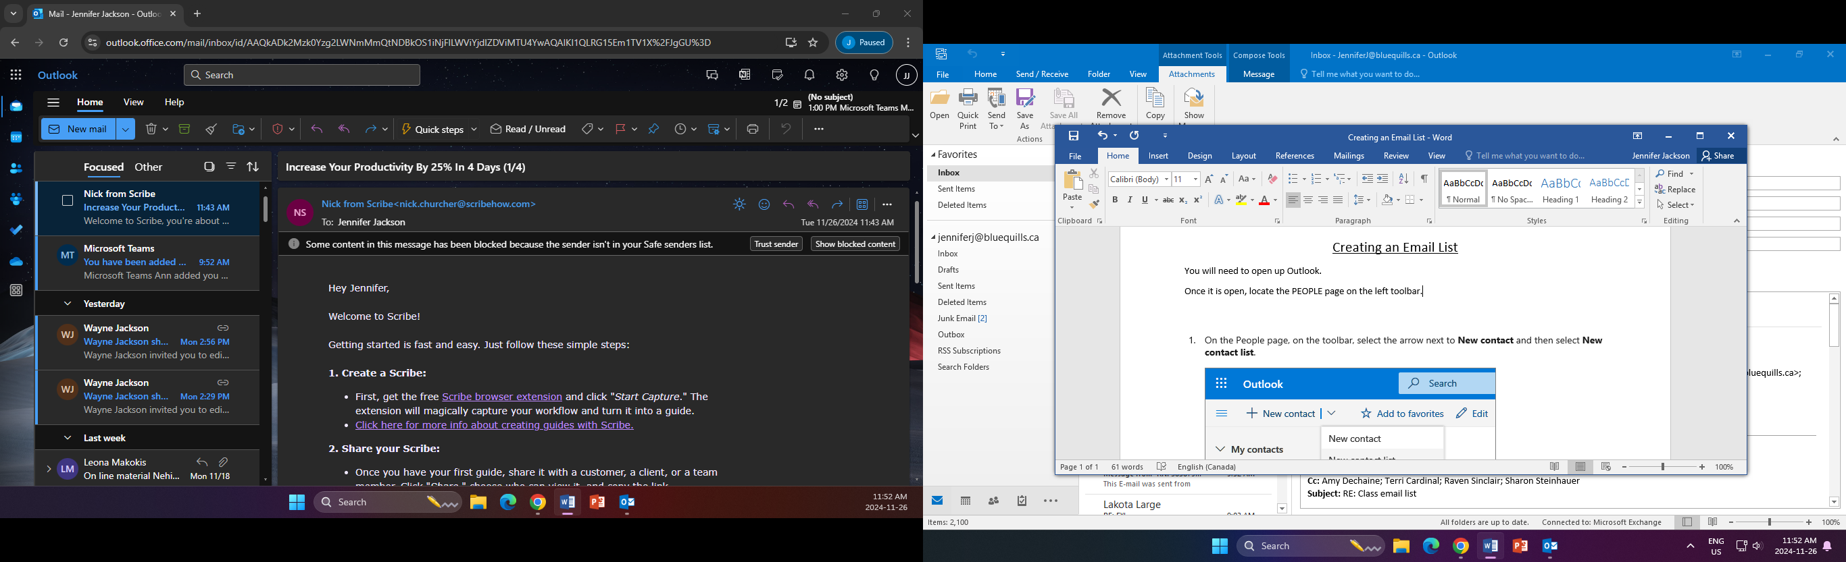
- Once it is open, locate the PEOPLE page on the left toolbar. It is within the Green circle below.

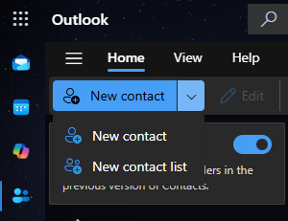
- On the People page, on the toolbar, select the arrow next to New contact and then select New contact list.

- Enter a name for the list, and then add names or email addresses.
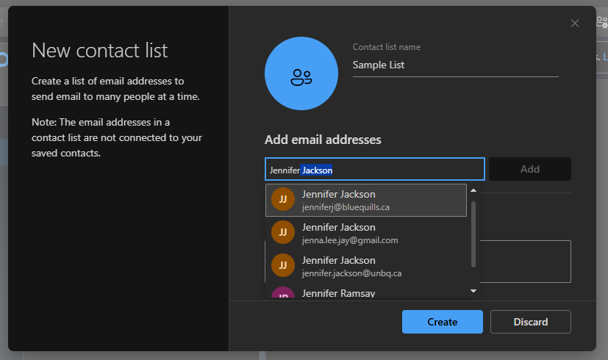
- Select Create.

